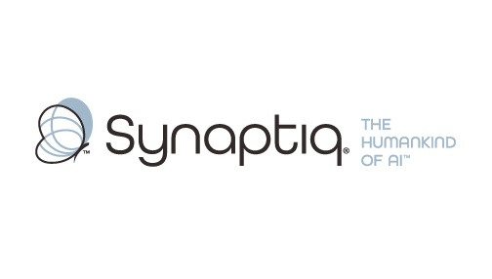
______________________________________________________________________
 | Stephen Sklarew  CEO & Co-Founder, Synaptiq  AI Strategy & Workforce Transformation | "The Humankind of AI"

Overview
Stephen Sklarew is a seasoned executive with over 30 years of experience helping organizations thoughtfully integrate technology to strengthen human capabilities rather than replace them. As CEO of Synaptiq, he specializes in strategic workforce planning and AI implementation that aligns with organizational values and long-term talent development. Stephen's expertise in Analytics Lifecycle Management and organizational transformation has helped companies navigate technology adoption while preserving culture and building sustainable competitive advantages. His approach emphasizes the proprietary AIQ® methodology, which assesses organizational readiness and designs AI integration strategies that enhance employee capabilities and create meaningful business value. Stephen's philosophy of "The Humankind of AI" resonates with organizations seeking responsible technology adoption that puts people first.
Background & Expertise
Stephen Sklarew is a seasoned business and technology executive with over 30 years of experience helping organizations navigate strategic workforce transformation and technology integration. His expertise spans organizational design, analytics strategy, and operational excellence, with a particular focus on helping companies thoughtfully adopt AI and automation while preserving their cultural values and investing in long-term talent development.
As CEO and cofounder of Synaptiq, an AI strategy and solutions firm founded in 2015, Stephen has guided numerous organizations through the complex process of integrating AI capabilities without compromising workforce stability or organizational culture. His approach emphasizes strategic planning over rapid implementation, ensuring that technology serves to enhance human capabilities rather than replace them. This philosophy aligns closely with organizations that prioritize employee care and sustainable growth.
Prior to Synaptiq, Stephen held senior positions at companies like Sage Software, CEB (now Gartner), and Ernst & Young LLP, where he developed deep expertise in Project Lifecycle Management and Analytics Lifecycle Management. His experience includes leading technology initiatives across diverse sectors including healthcare, financial services, and large-scale operations, giving him unique insights into how different organizational cultures can successfully integrate emerging technologies.
Under Stephen's leadership, Synaptiq developed the proprietary AIQ® methodology, a comprehensive framework that begins with organizational readiness assessment and guides clients through strategic planning, capability mapping, and thoughtful implementation. This approach ensures that AI integration strengthens existing teams while creating pathways for professional development and role evolution. Stephen's work has consistently focused on scenario modeling and future-state planning that helps organizations capture efficiency gains while maintaining their commitment to workforce development.
Stephen is recognized as a thought leader in responsible AI adoption and organizational transformation, frequently sharing insights on how companies can leverage technology to enhance human potential. His "Humankind of AI" philosophy emphasizes that the most successful AI implementations are those that amplify human ingenuity and preserve the cultural values that drive organizational success. Stephen holds a BS in Biology from Virginia Tech.
Relevant Experience
- Strategic Workforce Planning & AI Integration: Over 30 years of experience helping organizations navigate technology-driven workforce transformation while preserving culture and investing in talent development. Specialized in designing AI adoption strategies that enhance human capabilities rather than replace them.
- Analytics Lifecycle Management & Performance Systems: Deep expertise in building and optimizing analytics teams and performance measurement systems. Developed frameworks for evolving analytics capabilities as automation increases, ensuring teams remain strategically valuable.
- AIQ® Organizational Readiness Assessment: Created and deployed proprietary methodology for evaluating organizational AI maturity across four dimensions: leadership foundations, data infrastructure, existing capabilities, and cultural readiness for change.
- Scenario Modeling & Future-State Planning: Extensive experience in developing multiple future-state scenarios for workforce evolution, helping leadership teams understand efficiency opportunities while maintaining organizational stability and growth capacity.
- Large-Scale Operations & Enterprise Analytics: Led technology and analytics initiatives across diverse industries including healthcare, financial services, and complex operational environments. Experience working with organizations managing thousands of locations and distributed teams.
- Culture-Aligned Technology Implementation: Proven track record of designing technology adoption strategies that align with organizational values and leadership philosophy. Specialized in conservative, thoughtful implementation approaches that prioritize long-term sustainability.

